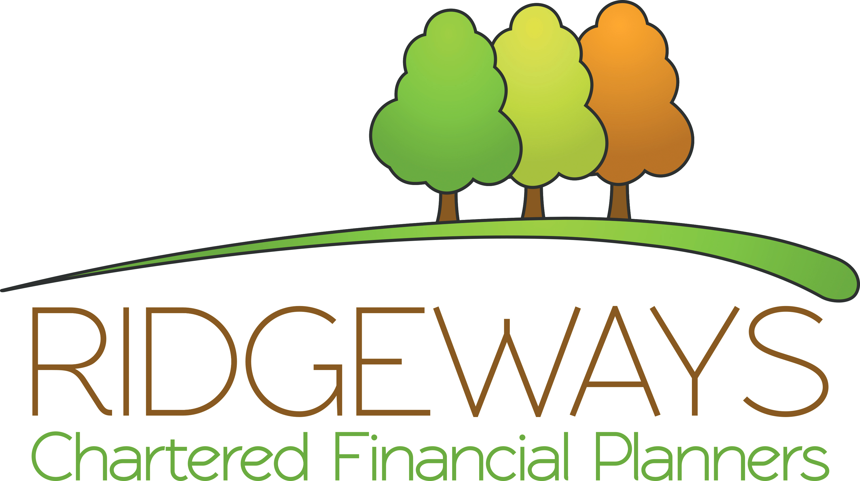

Fair Value Statement
June 2024

Ridgeways (FP) Ltd
3 Wingbury Courtyard
Wingrave
Bucks
HP22 4LW
01296 482423
info@ridgewaysfp.co.uk
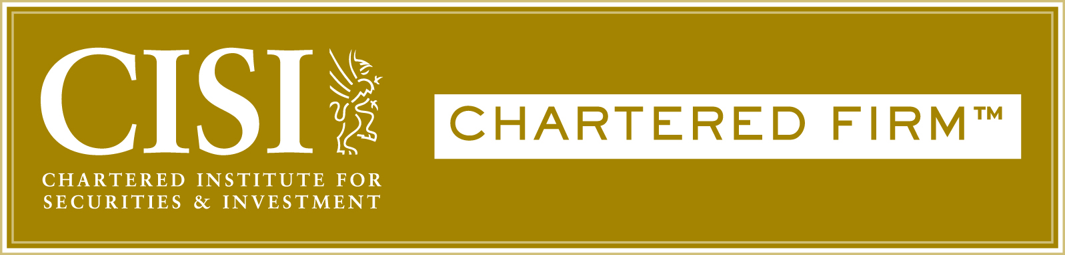

About Us

Introduction
This document is aimed at providing you with a brief overview of our firm and to introduce our services.
In this document, we intend to illustrate how we assess value and whether there is fair value between the total price of the service and the benefits and their quality that our clients receive.
We are a Chartered Independent Financial Advice firm based in the Aylesbury area. We have been advising private clients since 2008 and we pride ourselves on our client-first approach to service.
Our firm is owned and run by David Mills and Kevin Blake, who between them have over 40 years of experience as financial advisers and who take a very hands-on approach to the advice process. Our specialist areas are retirement planning, investing and inheritance tax planning.
We have a strong working relationship with local solicitors and accountants that allows us to take a joined-up holistic approach to your finances. It is our view that it is not possible to provide good quality financial advice without taking into consideration not just your financial situation, but also your tax position, your objectives, and the plans you have for your financial legacy.
Our service proposition has been designed to meet the needs and objectives of our clients and to ensure fair value is received by engaging with our service.
We work mainly with clients who are still working and building their assets, planning for retirement, or enjoying their retirement years. Our service proposition is most suitable for clients who have overall assets of £250,000 or income more than £100,000 per annum.
Our clients benefit not only from the tangible financial benefit of focused goals and objectives for their pensions and investments but also the less tangible benefits of knowing that they have someone who will guide them through the maze of financial services, has their best interests at heart and will help to prevent mistakes being made.
Investing, whether that is through an ISA, Pension or other vehicle, is a long-term project that, at times, requires perseverance and an ability to not lose sight of the end objective. This can be hard to do, especially in an uncertain world, but is so much easier when you can count on experience and integrity to keep you on the straight and narrow path that leads to financial success.

The Value of our Service

Chartered Financial Planning Business
Being recognised as a Chartered Financial Planning Firm means we are committed to the highest standards of professional competency, ethical standards, and integrity. We represent the gold standard in financial planning. We know this gives our clients a great deal of comfort.

Best Practice Member Firm Business
By leveraging the quality and services of an organisation like Benchmark, a Schroders plc group company, we have comfort that we will remain at the leading edge of our profession, ensuring we maintain a “Best Practice” approach to serving our clients. Many of the benefits we derive, we see as having direct value add relevance for our clients, including:

- The provision of an independent complaints handling process for all our clients,
- enhanced professional indemnity insurance.
- integrated client technology systems, including the Wealth Platform
- independent compliance supervision of our advisers and the suitability of our client advice.

Our Proposition – Initial Advice
Our advice process generally utilises the following structure:

- Discovery Meeting – This establishes whether we can help you in achieving your goals.
- Full ‘get to know you’ meeting – here we delve more deeply into your situation, sometimes known as fact finding. This provides us and you with context for all the advice that we give.
- Establish your goals and objectives – this enables us to make sure that the advice that we give is relevant to what you are trying to achieve.
- Establish your priorities – here we get to understand what is of the most import or urgency to you so that we can focus on dealing with that before considering other needs that you might have.
- Establish your attitude to risk and capacity for loss – a very important step in the process is coming to an agreement on what level of loss would be tolerable on a portfolio over a given timescale and establishing how any loss would impact your plans.
- Analysis of existing planning – an essential step in any advice that we give will include understanding what plans you have in place and what role they will continue to play in your future.
- Research of potential solutions – we will research the whole available market and find the most appropriate solution which we will then present to you in a written report.
- Construct a holistic financial plan – using tools such as cash flow modelling, we will help you put together a plan for the future taking into account all of the areas of potential concern
- Meet to discuss the financial plan and recommendations – it is important that you have the opportunity to discuss our recommendations and query any areas that you are unsure about.

- Agree implementation – the conclusion to all the above will be to decide which of our recommendations are to be taken forwards. We will carry out the implementation of any accepted recommendations on your behalf.

We believe that we are competitively priced offer fair value for our advice services. Our minimum fee of £1,500 reflects the fact that there is a minimum amount of work that will apply to all clients, though we feel that it is appropriate to apply a decency cap of £10,000. Please see the main Service Charter for more details on our charges.

Advisory Services – Annual Review Service with Cash Flow Planning / Forecasting
It is very important to periodically review your plans to make sure that they remain on course. Our review service looks not only helps you understand how your investments have performed over the last 12 months but also whether that performance, and any legislative or tax changes, have affected your plans.

Cash flow planning allows us to scenario test your plans against historical market events and simulate how our clients’ goals could be impacted by these types of events. It allows us to show how risk events might impact portfolios. It’s a really great way to help you understand more about investment risks and how it translates to the plans you have in place. It helps you to feel more informed and comfortable about your plans.

We believe that there is a minimum amount of work that will always be required on reviewing a client’s arrangements, although not necessarily increasing in line with the amount of money that we advise on, although there are additional risks attached as the amount of money increases. Additionally multiple products can add complexity. Thus, we have put in place a minimum charge of £1,250 (per annum), a sliding scale and a decency cap of £7,500 (per annum) that we believe reflects this.

Advisory Services – Family Protection Planning
It may be an uncomfortable subject, but we all need to plan for the unforeseen in life and how this would impact ourselves and our family. We can help you to consider different scenarios which could occur and identify if there are any shortfalls in your protection planning. We can explain what options you have to address these shortfalls and how they would ensure you and your family are able to maintain your lifestyle and still meet your longer-term financial goals, in the event of ill health or death.

We have access to professional tools and paraplanning resources to conduct analysis and research to find the best/most suitable product.

Advisory Services – IHT and Estate Planning
We have a high level of experience and knowledge regarding the tax position of an estate’s assets. We can help to understand the value of future liabilities and design and implement strategies to reduce this potential burden, often saving clients thousands of pounds in potential tax charges. We will co-ordinate with other professionals in this regard to ensure that your wishes are reflected in your wills.

Advisory Services – Retirement Planning
Retirement is for many potentially the most disruptive key life phase. This is an area of planning which deserves significant time in reviewing for our clients each year. Often in the background, checking on progress of plans and investments you have made to fund your life in retirement. Adapting to market swings and modelling various impact scenarios. Retirement planning is one of the most valuable services we provide our clients.

Many of our clients are currently in retirement, following our advice and drawing on their assets to live a stress-free life in retirement. Our retirement planning takes the worry away from our clients.

Advisory Services – Tax Efficiency
Making sure we consider tax reliefs and allowances, enables clients to maximise their after-tax wealth. If you don’t take advantage of annual tax reliefs, then you could quite literally be paying more tax than you need to. We can evidence the amount you have potentially saved through our planning.

Advisory Services – Market and Product Research and Analysis
To recommend the most suitable solutions for our clients, we use professional tools to conduct research and analysis of provider and product solutions. This ensures we can make recommendations to best meet your needs and goals.

Non-advisory Services – Other services
Life Goals Planning

To help clients consider their short / medium / long term goals in life and provide financial solutions to help them in their plans to achieve these goals.

Financial Coaching

- Financial Coaching can add value at various times throughout the financial planning journey and help you to make considered financial decisions.
- Amounts to invest to meet your goals.
- How and when to release capital or take income.
- Reassurance in volatile market conditions
- Understand how markets work and the journey you can expect.
- Understanding legislation and tax changes
- Behavioural guidance - we help to take the emotion out of financial decision making and help clients avoid falling into common mistakes.

Education Planning

Many clients want to support their children through university, and we can help you put in place a financial plan to meet these costs in full or in part. This will provide you with the knowledge and peace of mind that this very important goal is in hand and will be reviewed year on year to make sure you are on track.

Maintaining professional competency – Annual CPD

As a Financial Planner, each year we evidence the learning activities we have completed to maintain competence in our role and improve our knowledge This allows us to continue providing suitable and up to date advice to our clients, year on year.

Our Investment Proposition (and Philosophy)
Philosophy and Investment Research Methodology

- Our investment proposition is researched to provide the most suitable investment solutions to cater for your needs. We choose to outsource investment management to professional money managers. Our skill is in selecting which approach is best suited to you given the level of risk that you want to take, the level of engagement that you want with your portfolio and any other preferences, for example ethical/sustainable, that you might have We have the time and professional skillset to monitor your investments and the investment managers. To make sure we stay on track to meet your goals we tend to your investments while you give all the other things in life your full attention.

- We believe that, for many clients, it is hard to justify anything other than a passive portfolio because research has shown time and time again that active management fails to consistently provide a higher return, whilst at the same time having higher charges that act as a drag on performance.

- We use risk driven benchmarks as a measure of market performance.

- Our investment proposition is researched to provide the most suitable investment solutions to cater for your needs.

- This ultimately gives our clients great comfort that their investments are being managed by investment professionals and their financial plans are being looked after by highly qualified financial planning professionals. This is the value that a relationship with our firm provides. It’s what our clients pay for.

Discretionary Fund Management / Multi Asset Portfolios etc.

- For clients that want a higher level of engagement with the way that their investments are managed, need a bespoke portfolio for tax reasons or require an ethical/sustainable portfolio with specific inclusions or exclusions we recommend a Discretionary Fund Manager.

Centralised Investment Proposition

- We have carried out centralised research for different client requirements and review this regularly to ensure its continued suitability.

Rebalancing

In rare cases, where a client’s investment needs cannot be met through a single fund solution or through a Discretionary Fund Manager, we will seek to re-balance a portfolio at each review.

- This is a proactive investment management service which helps to keep your investments on track to meet your goals and saves you money through utilisation of your annual capital gains tax allowances.

- Helps to ensure your investments and selection of funds / asset classes remain aligned to your chosen attitude to risk and capacity for loss.

Technology
One of the reasons we chose to work with Benchmark, was their technology. Something they have won numerous awards for. Ultimately backed by Schroders, we have every confidence that the security of our client’s information within Benchmark’s client management technology systems, is in very safe hands. This decision is something we know our clients expect us to get right. It’s incredibly important to them and a reason they feel safe working with us.

Staff / Adviser Training and Development Programmes
All our advisory staff have to maintain their professional knowledge through CPD programmes. We encourage diversity in learning and evaluate what has been learned through one-to-one discussions.

General Value Statements - Working with a Financial Adviser – Tangible and Intangible Benefits
Working with a professional financial planner provides expertise and peace of mind.

We build multi decade trust-based relationships with our clients. We get to know what really matters most to them and their families. What they are trying to achieve in life and help them to achieve it.

Our relationships are often the longest standing relationships our clients have. They lean on us for so much more than the financial plans we cultivate and manage for them. This doesn’t happen without trust.

Summary
Considering all areas included in the assessment of value, we believe the service provided is demonstrating value overall and our service proposition along with this value statement has been approved by our network, Best Practice IFA Group Ltd

Important information: Best Practice IFA Group Limited is authorised and regulated by the Financial Conduct Authority, registration number 223112. Registered in England and Wales No 04490633. Evolution Wealth Network Limited is authorised and regulated by the Financial Conduct Authority, registration number 591218. Registered in England and Wales No 08229133. Registered office: Broadlands Business Campus, Langhurst Wood Road, Horsham, West Sussex, England, RH12 4QP.

